

**EduCare: AI Tutor and Health Assistant for Autism Support**

**FINAL YEAR PROJECT PHASE-I**

Submitted by

Saira Arshad (70126012)

Haseeb Tariq (70109359)

Maheen Qamar (70126610)

Project Supervisor:

Mr. Mujahid Rafique

BACHELOR OF SCIENCE IN SOFTWARE ENGINEERING

DEPARTMENT OF SOFTWARE ENGINEERING, UNIVERSITY OF LAHORE

Mention Date here

**FINAL YEAR PROJECT PHASE-I DOCUMENTATION**

**STATEMENT OF SUBMISSION**

This is to certify that Saira Arshad Roll No. 70126012, Haseeb Tariq Roll No. 70109359 and Maheen Qamar Roll No. 70126610 have successfully submitted to the University of Lahore in partial fulfillment of the requirement for the award of degree of Bachelors of Science in Software Engineering (BSSE)

|  |  |  |
| --- | --- | --- |
| By: |  | |
| * Name Haseeb Tariq | (SAP ID) | 70109359 |
| * Name Saira Arshad | (SAP ID) | 70126012 |
| * Name Maheen Qamar | (SAP ID) | 70126610 |

**PROJECT ADVISOR**

Mujahid Rafique

**Mention Supervisor name**

**Senior Lecturer**

(**Designation, UOL) Department of SE**

ABSTRACT

This AI-driven platform offers holistic support for children with Autism Spectrum Disorder (ASD) and their caregivers. By initiating with a personalized assessment to determine the child’s developmental stage and ASD level, the app customizes its features to suit individual needs. It incorporates an AI-powered chatbot to guide parents on autism-related concerns and enhance their decision-making. For children, the app provides an AI tutor delivering tailored learning modules, interactive games, and activities to foster cognitive, social, and behavioral growth. Additionally, the platform includes a progress-tracking system, offering caregivers detailed insights into developmental milestones and achievements. With its user-friendly design and integration of learning, parental guidance, and progress monitoring, the app empowers families to navigate ASD challenges with comprehensive and meaningful support.

**DEDICATION**

With hearts full of gratitude and compassion, we dedicate this project to our Almighty God, whose guidance and blessings have illuminated every step of this journey.

To our beloved parents, who have been our unwavering pillars of strength, and to our mentors, whose wisdom and encouragement have shaped our vision—your faith in us has been our greatest inspiration.

This work is also a tribute to the courageous children living with Autism Spectrum Disorder and their extraordinary parents, whose resilience and love transcend all challenges. It is our hope that this platform serves as a beacon of support, empowerment, and understanding for all who walk this path.

May this endeavor bring comfort, growth, and hope to the lives it touches.

Acknowledgement

First and foremost, we are incredibly appreciative of **Allah Almighty**, whose unending blessings and direction have made it possible for us to start and finish this endeavor. None of this would have been possible if it weren't for His kindness and mercy.  
We sincerely thank **Mr. Mujahid Rafique**, our supervisor, for his significant support, encouragement, and commitment along this trip. His knowledge and guidance have been crucial in determining the course and outcome of this endeavor.  
We also want to sincerely thank **Ms. Sonia Altaf**, our external supervisor, for her continuous support and constructive criticism. Her helpful criticism has really improved our work.  
Our sincere gratitude is extended to **Mr. Dayyan**, our helpful assistant, for his kind support, tolerance, and readiness to mentor us at every challenging step.

Lastly, we are immensely thankful to all our team members for their hard work, collaboration, and commitment. It is through our collective efforts and shared determination that this project has come to fruition.

To everyone who contributed to this endeavor, directly or indirectly, we are forever grateful.

**Haseeb Tariq**

**Saira Arshad**

**Maheen Qamar**

Table of Contents

**Chapter 01: Introduction to the Problem** 7

**1.0.** **Introduction:** 7

**1.1.** **Purpose**: 8

**1.2.** **Objective:** 8

**1.3.** **Existing Solution:** 9

**1.4.** **Gap Analysis and Proposed Solution:** 10

**Chapter 02: Software Requirement Specification** 10

**2.1.** **Introduction** 10

2.1.1. Purpose 10

2.1.2. Scope 11

2.1.3. Definitions, acronyms and abbreviations 11

**2.2.** **Overall Description** 12

2.2.1 Product Perspective 12

2.2.1.1 System Interfaces 12

2.2.1.2 User Interfaces 12

2.2.1.3 Hardware Interfaces 12

2.2.1.4 Software Interfaces 12

2.2.1.5 Communication Interfaces 12

2.2.1.6 Memory 13

2.2.1.7 Operations 13

2.2.2 Product Functions 13

2.2.3 User Characteristics 17

2.2.4 Constraints 17

2.2.5 Assumptions and Dependencies 18

2.2.6 Apportioning of Requirements 18

**2.3. Specific Requirements** 18

2.3.1 Functional Requirements 18

2.3.2 Non-Functional Requirements 19

**Chapter 03: Use Case Analysis** 20

3.1 Aggregated Use Case Diagram 20

3.2 Individual Use Cases and Use Cases Details 21

3.2.1 Create Account 21

3.2.2 Login 21

3.2.3 Profile Management 22

3.2.4 Initial Assessment 23

3.2.5 Learning Modules 24

3.2.6 Games and Activities 24

3.2.7 Progress Report 25

3.2.8 Chatbot 26

3.2.9 Notification and Reminders 27

3.2.10 Settings 27

3.2.11 Feedback 28

3.2.12 Logout 29

**Chapter 04: Design** 30

4.1 Architecture Diagram 30

4.2 ERD with data dictionary 30

4.3 Data Flow Diagram 30

4.4 Class Diagram 30

4.5 Activity Diagram 30

4.6 Sequence Diagram 30

4.7 Collaboration Diagram 30

4.8 State Transition Diagram 30

4.9 Component Diagram 30

4.10 Deployment Diagram 30

List of Tables

**Table 1: FR_01 Create Account** 13

**Table 2: FR_02 LOGIN** 13

**Table 3:FR_03 PROFILE MANAGEMENT** 14

**Table 4:FR_04 INTIAL ASSESSMENT** 14

**Table 5:FR_05 LEARNING MODULES** 14

**Table 6:FR_06 GAMES AND ACTIVITIES** 15

**Table 7:FR_07 PROGRESS REPORT** 15

**Table 8:FR_08 CHATBOT** 15

**Table 9:FR_09 NOTIFICATION AND REMINDER** 16

**Table 10:FR_10 SETTINGS** 16

**Table 11:FR_11 FEEDBACK** 16

**Table 12:FR_12 LOGOUT** 17

**Table 13 Functional Requirements** 19

List of Figures

Figure 1 Aggregated Use Case Digram 21

Figure 2 Use Case - Create Account 22

Figure 3 Use Case - Login 23

Figure 4 Use Case - Profile Management 23

Figure 5 Use Case - Initial Assessment 24

Figure 6 Use Case - Learning Modules 25

Figure 7 Use Case - Games and Activities 26

Figure 8 Use Case - Progress Report 26

Figure 9 Use Case - Chatbot 27

Figure 10 Use Case - Notification and Reminders 28

Figure 11 Use Case - Settings 29

Figure 12 Use Case - Feedback 29

Figure 13 Use Case - Logout 30

Figure 14 Architecture Diagram 31

Figure 15 Entity Relationship Diagram 32

Figure 16 ERD Data Dictionary 34

Figure 17 ERD Logical Schema 34

Figure 18 Data Flow Diagram Level 0 35

Figure 19 Data Flow Diagram Level 1 36

Figure 20 Class Diagram 37

Figure 21 Activity Diagram - Login 38

Figure 22 Activity Diagram - Create Account 39

Figure 23 Activity Diagram - Profile Management 40

Figure 24 Activity Diagram - Initial Assessment 41

Figure 25 Activity Diagram - Learning Module 42

Figure 26 Activity Diagram - Games and Activites 43

Figure 27 Activity Diagram - Progress Report 44

Figure 28 Activity Diagram - Chatbot 45

Figure 29 Activity Diagram - Notification and Reminders 46

Figure 30 Activity Diagram - Settings 47

Figure 31 Activity Diagram - Feedback 48

Figure 32 Activity Diagram - Logout 49

Figure 33 Sequence Digram - Create Account 50

Figure 34 Sequence Digram - Login 50

Figure 35 Sequence Digram - Profile Management 51

Figure 36 Sequence Digram - Initial Assessment 51

Figure 37 Sequence Digram - Learning Module 52

Figure 38 Sequence Digram - Games and Activities 52

Figure 39 Sequence Digram - Progress Report 53

Figure 40 Sequence Digram - Chatbot 53

Figure 41 Sequence Digram - Notifications and Reminders 54

Figure 42 Sequence Digram - Settings 54

Figure 43 Sequence Digram - Feedback 55

Figure 44 Sequence Digram - Logout 55

Figure 45 Collaboration Diagram - Create Account 55

Figure 46 Collaboration Diagram - Login 56

Figure 47 Collaboration Diagram - Profile Management 56

Figure 48 Collaboration Diagram - Initial Assessment 56

Figure 49 Collaboration Diagram - Learning Module 57

Figure 50 Collaboration Diagram - Games and Activities 57

Figure 51 Collaboration Diagram - Progress Report 57

Figure 52 Collaboration Diagram - Chatbot 58

Figure 53 Collaboration Diagram - Notifications and Reminders 58

Figure 54 Collaboration Diagram - Settings 58

Figure 55 Collaboration Diagram - Feedback 58

Figure 56 Collaboration Diagram - Logout 59

Figure 57 State Transition Diagram 59

Figure 58 Component Diagram 60

# **Chapter 01: Introduction to the Problem**

# **Introduction:**

Our app is a comprehensive, AI-driven platform designed to support children with Autism Spectrum Disorder (ASD) and their caregivers. It begins with an **initial assessment** to evaluate the child’s ASD level and developmental stage, ensuring a fully personalized experience tailored to their unique needs. The app features an **AI-powered chatbot** that provides parents with expert guidance on autism-related concerns, enhancing their understanding and decision-making.

For children, the app offers an **AI tutor** delivering personalized learning modules, interactive games, and activities that promote cognitive, social, and behavioral development. Parents and caregivers can leverage the **progress tracking system** to monitor their child’s achievements and developmental milestones through detailed, data-driven insights.

With its **intuitive design and accessibility**, the app seamlessly integrates learning, parental guidance, and progress monitoring into a single, cohesive platform. This innovative tool empowers families by addressing both educational and caregiving needs, providing meaningful support for children with autism and their loved ones.

# **Purpose**:

The purpose of this app is to create a comprehensive, technology-driven solution that supports children with Autism Spectrum Disorder (ASD) and their caregivers in meaningful ways. By offering personalized learning experiences through AI-driven activities and educational modules, the app aims to enhance the cognitive, social, and behavioral development of children with autism. It also provides caregivers with reliable resources, including an AI-powered chatbot for expert guidance and decision-making support, making it easier to navigate the challenges of autism care. Additionally, the app simplifies progress monitoring by delivering data-driven insights that help families and educators track and evaluate the child’s growth and achievements over time. By addressing the fragmentation found in existing solutions, the app integrates learning, guidance, and progress tracking into a user-friendly and cohesive platform, ultimately improving the quality of life for both children with autism and their families.

# **Objective:**

**Add an Initial Assessment Feature:** Implement an assessment at the start of the app to evaluate the child’s ASD level (e.g., mild, moderate, severe) for personalized activity and module recommendations.

**Develop an AI-Powered Chatbot:** Create a chatbot that provides parents with reliable answers to general autism-related questions, including behavioral concerns and guidance to enhance parental understanding and decision-making.

**Implement an AI Tutor for Learning and Activities:** Design an AI-based tutor that provides customized learning modules, games, and activities to enhance cognitive and social skills.

**Enable Progress Tracking and Monitoring:** Allow caregivers to track developmental milestones and create meaningful progress reports.

**Enhance User Experience and Accessibility:** Make it accessible, with ease of navigation for kids as well as parents, using the interfaces.

**Integrate a Comprehensive Support System:** Combine learning, guidance, and monitoring into a coherent all-in-one platform.

# **Existing Solution:**

|  |  |  |  |  |  |  |  |
| --- | --- | --- | --- | --- | --- | --- | --- |
| **Feature** | **Cognoa** | **Prologue2Go** | **Autism iHelp** | **AutiSpark** | **Inner Voice** | **Otsimo** | **Proposed Solution** |
| **Target Audience** | Parents and clinicians working with children suspected of autism | Nonverbal children, including those with autism | Children with autism, educators and caregivers | Children on the autism spectrum | Children with autism, particularly nonverbal or minimally verbal | Children with autism, educators and caregivers | Children with autism and their caregivers, including parents and educators |
| **Key Features** | AI-powered diagnostic tool, personalized activities, developmental insights | AAC tool for nonverbal individuals, customizable interface, progress tracking | Early intervention educational app, visual learning (flashcards, interactive tasks), progress tracking | Interactive learning activities (sorting, matching, memory games), progress reports | Communication aid using pictures and symbols, generates spoken words | Educational games for language and social skills, progress tracking | Initial assessment, AI-driven learning, chatbot for parental guidance, progress tracking, integrated support system |
| **Communication Support** | ❌ | ✅ | ❌ | ❌ | ✅ | ❌ | ✅ |
| **Educational Activities** | ✅ | ❌ | ✅ | ✅ | ❌ | ✅ | ✅ |
| **Progress Tracking** | ✅ | ✅ | ✅ | ✅ | ❌ | ✅ | ✅ |
| **Parental Support (Chatbot)** | ❌ | ❌ | ❌ | ❌ | ❌ | ❌ | ✅ |
| **Therapeutic Guidance** | ❌ | ❌ | ❌ | ❌ | ❌ | ❌ | ✅ |
| **AI-Driven Personalization** | ✅ | ❌ | ❌ | ❌ | ❌ | ❌ | ✅ |
| **Integrated System** | ❌ | ❌ | ❌ | ❌ | ❌ | ❌ | ✅ |
| **Pricing** | Paid (may be insurance-covered) | Paid (one-time purchase) | Free with in-app purchases | Paid (one-time or subscription) | Paid with optional customization | Freemium with subscription | Freemium with optional premium features |

# **Gap Analysis and Proposed Solution:**

**Problem with Existing Systems**

1. **Fragmentation**: No single platform addresses communication, education, parental guidance, and therapeutic needs together.
2. **Limited Parent Involvement**: Existing systems do not adequately equip parents with tools to monitor and guide their child’s progress.
3. **Absence of Integration**: Parents often must rely on multiple tools, leading to inefficiencies and incomplete support.
4. **Underutilized AI Potential**: Current systems fail to harness AI to provide personalized and adaptive learning or behavior management.

**Addressing the Gaps**

Our app is a comprehensive solution for children with ASD and their caregivers. It first starts with an assessment for personalizing activities, games, and educational modules according to the child's needs. The AI tutor provides an engaging module and activities to sharpen cognitive and social skills; the AI chatbot delivers expert advice on autism-related concerns. A progress tracker monitors milestones, generates reports, and provides data-driven insights for informed decision-making. The app has a child-friendly design and smooth integration of learning, guidance, and tracking. This makes autism care easy, empowers families, and fosters development.

# **Chapter 02: Software Requirement Specification**

# **Introduction**

This Software Requirements Specification (SRS) document serves as a foundational guideline for the development team and stakeholders involved in the creation of our AI-driven platform supporting children with Autism Spectrum Disorder (ASD) and their caregivers.

## Purpose

The purpose of this document is to provide a clear, detailed, and structured overview of the system’s requirements, ensuring alignment between stakeholders and the development team. It establishes a shared understanding of the project’s scope, objectives, and deliverables, acting as a bridge between conceptualization and implementation. This document will outline the functional, non-functional, and technical requirements essential for developing a system that meets the highest standards of usability, accessibility, and performance.

By adhering to this SRS, the development team will ensure the successful realization of a solution that aligns with stakeholder expectations while delivering meaningful and impactful support to its users.

## Scope

The software product, **EduCare: AI Tutor and Health Assistant for Autism Support**, is a comprehensive platform designed to assist children with “Autism Spectrum Disorder (ASD)” and their caregivers. This AI-driven application integrates advanced technologies to deliver personalized learning experiences, caregiver guidance, and developmental progress monitoring within a single, cohesive system.

**EduCare will do:**

* **Personalized Support:** Provide tailored learning modules and interactive activities to support the cognitive, social, and behavioral development of children with ASD.
* **Caregiver Assistance:** Offer AI-powered guidance to caregivers through an intuitive chatbot for addressing autism-related queries and enhancing decision-making.
* **Progress Tracking:** Enable caregivers to monitor the developmental milestones and achievements of children through detailed analytics and reports.

**EduCare will not do:**

* The application does not serve as a replacement for professional medical advice, diagnosis, or therapy.
* It does not provide real-time clinical intervention or therapeutic services.

**Application and Benefits:**  
EduCare is intended to be a valuable tool for families and caregivers, designed to:

* Improve the learning and developmental outcomes for children with ASD through engaging and personalized approaches.
* Empower caregivers with knowledge and resources to better support their child’s growth and well-being.
* Provide an accessible, user-friendly interface to simplify the caregiving and educational journey for families.

## Definitions, acronyms and abbreviations

**• Definitions:**

* **Autism Spectrum Disorder (ASD):** A developmental condition characterized by challenges with social interaction, communication, and repetitive behaviors, varying in severity across individuals.
* **AI Tutor:** An artificial intelligence system designed to deliver personalized educational content and activities tailored to a child’s developmental needs.
* **Caregiver:** A parent, guardian, or individual responsible for the care and support of a child with ASD.
* **Personalized Learning:** An educational approach tailored to meet the unique abilities, interests, and developmental needs of an individual learner.
* **Progress Tracking:** The systematic monitoring and reporting of a child’s developmental milestones and achievements over time.

**• Acronyms:**

* **ASD:** Autism Spectrum Disorder
* **AI:** Artificial Intelligence
* **UI:** User Interface
* **UX:** User Experience
* **SRS:** Software Requirements Specification
* **API:** Application Programming Interface
* **DBMS:** Database Management System

**• Abbreviations:**

* **EduCare:** AI-powered Learning and Tutoring Assistant for Autism Support (Project Name)
* **ML:** Machine Learning
* **DL:** Deep Learning
* **NLP:** Natural Language Processing

# **Overall Description**

## 2.2.1 Product Perspective

The **EduCare: AI Tutor and Health Assistant for Autism Support** is an independent and self-contained application designed to address the unique educational and caregiving needs of children with “Autism Spectrum Disorder (ASD)” and their families. It prioritizes accessibility, inclusivity, and a user-friendly interface to meet diverse user needs.

### 2.2.1.1 System Interfaces

The **EduCare: AI Tutor and Health Assistant for Autism Support** interacts with various system components to deliver its functionality effectively. It includes User Interface (UI), Database Interface, AI Processing interface, Third-Party API Integration, Security Interface, Progress Reporting Interface.

### 2.2.1.2 User Interfaces

The User Interface (UI) of **EduCare: AI Tutor and Health Assistant for Autism Support** will be user friendly allowing the children with ASD and guardians to easily navigate through the app with ease.

### 2.2.1.3 Hardware Interfaces

**EduCare** is a software-based platform and does not require strict hardware dependencies. However, to operate it requires (Tablets, Smartphones) and may require internet connectivity.

### 2.2.1.4 Software Interfaces

The **EduCare** may have dependencies on certain software components, such as databases, NLP models and programming languages. These dependencies will be specified during development and deployment process in order to ensure its seamless operation.

### 2.2.1.5 Communication Interfaces

The **EduCare** requires minimal communication interfaces including internet connectivity, backend protocols, push notifications, and accessibility tools.

### 2.2.1.6 Memory

The **EduCare** memory requirements will depend on the scale of the platform and the data load defined during system design.

### 2.2.1.7 Operations

The **EduCare** Core operations will include user login, assessments, activities, educational content, and progress reports, with backup and recovery for data integrity.

## 2.2.2 Product Functions

**Table 1: FR_01 Create Account**

|  |  |  |  |  |
| --- | --- | --- | --- | --- |
| ID: | FR_01 | | | |
| Name: | Create Account | | | |
| Description | Input | Output | Requirements | Basic Work Flow |
| Enter details to create account  for Children and Parents | Name, Email, Password etc. | Account Created | Internet connectivity required | Users enters his/her correct credentials and click submit button.  System save the record in the database. |

**Table 2: FR_02 LOGIN**

|  |  |  |  |  |
| --- | --- | --- | --- | --- |
| ID: | FR_02 | | | |
| Name: | Login | | | |
| Description | Input | Output | Requirements | Basic Work Flow |
| Enter Username and Password to log into the system for Children and Parents | Username  Password | User Login the system successfully | Internet connectivity and  Active account required | Users enters his/her correct credentials.  System checks from the database and matches the Username and Password. |

**Table 3:FR_03 PROFILE MANAGEMENT**

|  |  |  |  |  |
| --- | --- | --- | --- | --- |
| ID: | FR_03 | | | |
| Name: | Profile Management | | | |
| Description | Input | Output | Requirements | Basic Work Flow |
| Allow to update the profile information for Children and Parents | Children and Parents personal information | Updated Profile information | Internet connectivity and access to user’s database | Users must login the system  Navigate the profile management section  Update the information  Save the updated information in the database |

**Table 4:FR_04 INTIAL ASSESSMENT**

|  |  |  |  |  |
| --- | --- | --- | --- | --- |
| ID: | FR_04 | | | |
| Name: | Initial Assessment | | | |
| Description | Input | Output | Requirements | Basic Work Flow |
| Perform an initial assessment to determine the child’s ASD level | Select answers of pre-defined questions | Categorized Child’s ASD level | Internet connectivity and user must be logged in | Users answers the pre-defined questions.  Process the input through AL/ML model.  Display the child’s ASD level. |

**Table 5:FR_05 LEARNING MODULES**

|  |  |  |  |  |
| --- | --- | --- | --- | --- |
| ID: | FR_05 | | | |
| Name: | Learning Modules | | | |
| Description | Input | Output | Requirements | Basic Work Flow |
| Educational learning content based on child’s ASD level | Initial Assessment result | Educational content provided based on the result | Internet Connectivity required, Initial Assessment attempted, Trained AI Model | Processes the initial assessment  Categorize the ASD level  Display Educational content based on child’s ASD level |

**Table 6:FR_06 GAMES AND ACTIVITIES**

|  |  |  |  |  |
| --- | --- | --- | --- | --- |
| ID: | FR_06 | | | |
| Name: | Games and Activities | | | |
| Description | Input | Output | Requirements | Basic Work Flow |
| Provide interactive games and activities | Children’s assessment data, learning preferences | Engaging game and content provided, generate progress result | Internet Connectivity required to store progress results in database, Trained AI model | Based on child’s assessment data provide the game and activity.  Child engages in the game and activity.  Progress result are recorded to track progress. |

**Table 7:FR_07 PROGRESS REPORT**

|  |  |  |  |  |
| --- | --- | --- | --- | --- |
| ID: | FR_07 | | | |
| Name: | Progress Report | | | |
| Description | Input | Output | Requirements | Basic Work Flow |
| Child’s progress report | Data from learning, games and activities | Progress report generated based on child’s | Internet Connectivity required to download or view progress report | Child will educate from learning module, engage in games and activities and based on its progress/result report will be generated/updated.  Report can be viewed or saved. |

**Table 8:FR_08 CHATBOT**

|  |  |  |  |  |
| --- | --- | --- | --- | --- |
| ID: | FR_08 | | | |
| Name: | Chatbot | | | |
| Description | Input | Output | Requirements | Basic Work Flow |
| Chatbot will provide assistance to parent’s queries | Parent inputs query/problem | Solution to the problem will be generated | Internet Connectivity required, trained AI model for assisting the queries | Parent interacts with chatbot and enters their queries.  Chatbot processes the queries using AI trained model.  Chatbot provides relevant response to the query.  Feedback is conducted for the response to improve the model’s accuracy |

**Table 9:FR_09 NOTIFICATION AND REMINDER**

|  |  |  |  |  |
| --- | --- | --- | --- | --- |
| ID: | FR_09 | | | |
| Name: | Notification and Reminders | | | |
| Description | Input | Output | Requirements | Basic Work Flow |
| The system sends reminders for children to complete specific activities | User schedules activities and preferences | Timely notifications are displayed | Device notifications enabled | Retrieve activity schedule.  Check reminder settings. Generate and send notifications. |

**Table 10:FR_10 SETTINGS**

|  |  |  |  |  |
| --- | --- | --- | --- | --- |
| ID: | FR_10 | | | |
| Name: | Settings | | | |
| Description | Input | Output | Requirements | Basic Work Flow |
| Allows users to customize application preferences | Selected preferences | Updated settings in the user profile | User must be logged in  User interface for settings | User accesses settings.  Selects preferences Save changes. |

**Table 11:FR_11 FEEDBACK**

|  |  |  |  |  |
| --- | --- | --- | --- | --- |
| ID: | FR_11 | | | |
| Name: | Feedback | | | |
| Description | Input | Output | Requirements | Basic Work Flow |
| Enables users to submit feedback or suggestions | User gives feedback | Feedback stored in the database | User must be logged in  Feedback form/ popup, database for storing suggestions | Show feedback form/popup.  Fill and submit feedback. Save response in the database/model. |

**Table 12:FR_12 LOGOUT**

|  |  |  |  |  |
| --- | --- | --- | --- | --- |
| ID: | FR_12 | | | |
| Name: | Logout | | | |
| Description | Input | Output | Requirements | Basic Work Flow |
| Allows users to securely log out the app | Logout request | User session terminated | User authentication module | User initiates logout.  System ends the session. Redirect user to the login screen. |

## 2.2.3 User Characteristics

**1. Parents/Caregivers**

* **Educational Level**: High school to college-educated; basic knowledge of ASD.
* **Experience**: Limited exposure to ASD tools; familiar with smartphones and basic apps.
* **Technical Expertise**: Basic to moderate; can navigate user-friendly interfaces.
* **Primary Operations**: Viewing and tracking progress, downloading reports, interacting with a chatbot for assistance.

**2. Children with ASD**

* Educational Level: Varies by age and abilities; prefers visual and interactive content.
* Experience: Minimal with specialized tools; some exposure to learning apps or games.
* Technical Expertise: Minimal; relies on intuitive, sensory-friendly design.
* Primary Operations: Completing structured tasks, interacting with age-appropriate content for progress tracking.

## 2.2.4 Constraints

1. **Regulatory Policies**
   * Compliance with **GDPR** and **HIPAA** for data protection.
   * Adherence to **WCAG 2.1** for accessibility standards.
2. **Hardware Limitations**
   * Support for mid-range smartphones and tablets.
   * Offline functionality for essential features.
3. **Interfaces to Other Applications**
   * Seamless integration with accessibility tools and push notifications.
   * Compatibility with native OS features (iOS/Android).
4. **Parallel Operation**
   * Support for multiple users with independent profiles in one household.
5. **Audit Functions**
   * Maintain logs for critical actions (account creation, data updates, etc.).
6. **Control Functions**
   * Admin controls for caregivers to manage profiles and preferences.
7. **Higher-Order Language Requirements**
   * Use of modern, reliable programming languages (e.g., **Flutter**, **React Native**).
8. **Signal Handshake Protocols**
   * **SSL/TLS** encryption for secure data transmission.
9. **Reliability Requirements**
   * 99.5% system uptime and robust error handling for recovery.
10. **Criticality of the Application**

* Prioritize accuracy, responsiveness, and stability in critical features.

1. **Safety and Security Considerations**

* End-to-end encryption for data security.
* Multi-factor authentication (MFA) for user access.
* Regular security audits to ensure compliance.

## 2.2.5 Assumptions and Dependencies

1. **Assumptions**
   * Users are familiar with basic mobile app navigation.
   * Reliable internet connectivity is available for setup and cloud features.
   * The app is compatible with common iOS and Android devices.
   * User data will comply with data privacy laws (GDPR, HIPAA).
   * AI models will be trained on diverse data and continuously improve.
2. **Dependencies**
   * Third-party services for push notifications, cloud storage, and authentication (e.g., Firebase, AWS).
   * Mobile platform features (notifications, accessibility tools) must be available.
   * Integration with external APIs for content and payment gateways.
   * Security updates and compliance with encryption and data protection standards.
   * Device specifications (processing power, memory) affect app performance.

## 2.2.6 Apportioning of Requirements

In the event of software updates, there might be a need for additional requirements to address the issue. In the coming future, we have the opportunity to improve our application by incorporating more authentic and secure features.

# **2.3. Specific Requirements**

## 2.3.1 Functional Requirements

|  |  |  |
| --- | --- | --- |
| **FR_ID** | **Functional Requirement** | **Description** |
| FR_01 | Create Account | Enter details to create account  for Children and Parents |
| FR_02 | Login | Enter Username and Password to log into the system for Children and Parents |
| FR_03 | Profile Management | Allow to update the profile information for Children and Parents |
| FR_04 | Initial Assessment | Perform an initial assessment to determine the child’s ASD level |
| FR_05 | Learning Modules | Educational learning content based on child’s ASD level |
| FR_06 | Games and Activities | Provide interactive games and activities |
| FR_07 | Progress Report | Child’s progress report |
| FR_08 | Chatbot | Chatbot will provide assistance to parent’s queries |
| FR_09 | Notification and Reminders | The system sends reminders for children to complete specific activities |
| FR_10 | Settings | Allows users to customize application preferences |
| FR_11 | Feedback | Enables users to submit feedback or suggestions |
| FR_12 | Logout | Allows users to securely log out the app |

**Table 13 Functional Requirements**

## 2.3.2 Non-Functional Requirements

**Performance:** The system shall respond to user requests within few seconds for a smooth

user experience.

**Usability:** The system shall provide an intuitive user interface that is easy for children and

parents to navigate.

**Maintainability:** The system shall be designed to allow easy updates and maintenance.

**Reliability:** The system should be highly reliable and available to users at all times.

**Portability: EduCare** should be designed and developed using technologies and frameworks that allow for easy deployment across different environments.

**Design Constraints:**

* The system must have platform compatibility.
* UI/UX design must be simple and easy to use ensuring accessibility and usability on different devices.
* The design should comply with app accessibility standards.

**License Agreement:**

* The EduCare platform should comply with relevant copyright and licensing agreements for the educational resources and materials provided.
* The platform should clearly state the terms and conditions of use for parents and children’s, outlining any restrictions or permissions regarding the usage and distribution of the platform’s content.

# **Chapter 3: Use Case Analysis**

## 3.1 Aggregated Use Case Diagram

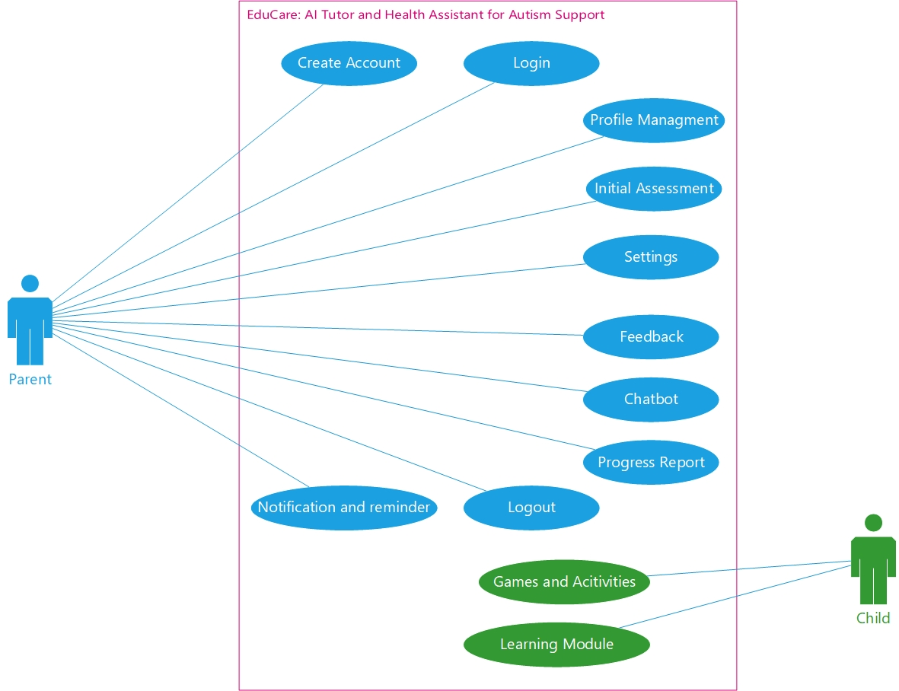

**Figure 1** **Aggregated Use Case Digram**

## 3.2 Individual Use Cases and Use Cases Details

### 3.2.1 Create Account

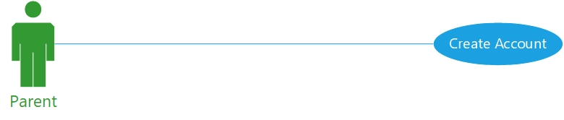

**Figure 2** **Use Case - Create Account**

**Use Case Detail:**

|  |  |  |
| --- | --- | --- |
| **Use Case ID** | UC_01 | |
| **Use Case Name** | Create Account | |
| **Description** | Enter details to create account  for Children and Parents | |
| **Primary Actor** | Parent | |
| **Secondary Actor** | System | |
| **Pre-Condition** | Internet connectivity required | |
| **Post-Condition** | Account Created | |
| **Basic Flow** | **Actor Action** | **System Action** |
|  | Users enters his/her correct credentials and click submit button. | System saves the record in the database. |
| **Alternate Flow** | Error message! Please enter correct details | |

**Table 3.2.1: Create Account**

### 3.2.2 Login

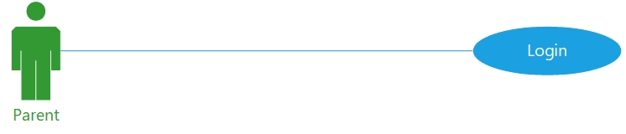

**Figure 3** **Use Case - Login**

**Use Case Detail**

|  |  |  |
| --- | --- | --- |
| **Use Case ID** | UC_02 | |
| **Use Case Name** | Login | |
| **Description** | Enter Username and Password to log into the system for Children and Parents | |
| **Primary Actor** | Parents | |
| **Secondary Actor** | System | |
| **Pre-Condition** | Internet connectivity  Active account required | |
| **Post-Condition** | User Login the system successfully | |
| **Basic Flow** | **Actor Action** | **System Action** |
|  | Users enters his/her correct credentials. | System checks from the database and matches the Username and Password. |
| **Alternate Flow** | Error message! Details are incorrect | |

**Table 3.2.2 Login**

### 3.2.3 Profile Management

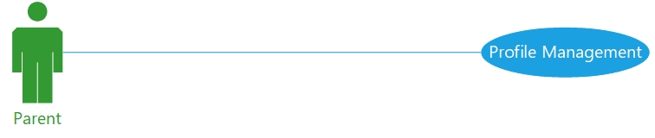

**Figure 4** **Use Case - Profile Management**

**Use Case Detail**

|  |  |  |
| --- | --- | --- |
| **Use Case ID** | UC_03 | |
| **Use Case Name** | Profile Management | |
| **Description** | Allow to update the profile information for Children and Parents | |
| **Primary Actor** | User | |
| **Secondary Actor** | System | |
| **Pre-Condition** | Internet connectivity and access to user’s database | |
| **Post-Condition** | Updated Profile information | |
| **Basic Flow** | **Actor Action** | **System Action** |
|  | Users must login the system  Navigate the profile management section  Update the information | Save the updated information in the database |
| **Alternate Flow** | Error message! Please fill out all required fields | |

**Table 3.2.3 Profile Management**

### 3.2.4 Initial Assessment

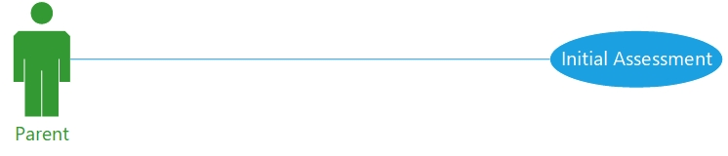

**Figure 5** **Use Case - Initial Assessment**

**Use Case Detail**

|  |  |  |
| --- | --- | --- |
| **Use Case ID** | UC_04 | |
| **Use Case Name** | Initial Assessment | |
| **Description** | Perform an initial assessment to determine the child’s ASD level | |
| **Primary Actor** | Parent | |
| **Secondary Actor** | System | |
| **Pre-Condition** | Internet connectivity and user must be logged in | |
| **Post-Condition** | Categorized Child’s ASD level | |
| **Basic Flow** | **Actor Action** | **System Action** |
|  | Users answers the pre-defined questions. | Process the input through AL/ML model.  Display the child’s ASD level. |
| **Alternate Flow** | None | |

**Table 3.2.4 Initial Assessment**

### 3.2.5 Learning Modules

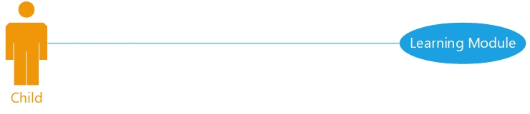

**Figure 6** **Use Case - Learning Modules**

**Use Case Detail**

|  |  |  |
| --- | --- | --- |
| **Use Case ID** | UC_05 | |
| **Use Case Name** | Learning Modules | |
| **Description** | Educational learning content based on child’s ASD level | |
| **Primary Actor** | Children | |
| **Secondary Actor** | System, Parents | |
| **Pre-Condition** | Internet connectivity required and assessment must be filled | |
| **Post-Condition** | Educational content provided based on the result | |
| **Basic Flow** | **Actor Action** | **System Action** |
|  | Child educates from learning content | Display Educational content based on child’s ASD level |
| **Alternate Flow** | None | |

**Table 3.2.5 Learning Modules**

### 3.2.6 Games and Activities

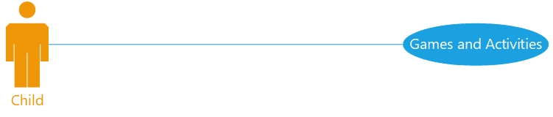

**Figure 7** **Use Case - Games and Activities**

**Use Case Detail**

|  |  |  |
| --- | --- | --- |
| **Use Case ID** | UC_06 | |
| **Use Case Name** | Games and Activities | |
| **Description** | Provide interactive games and activities | |
| **Primary Actor** | Children | |
| **Secondary Actor** | System, Parents | |
| **Pre-Condition** | Internet Connectivity required to store progress results in database, Trained Al Model | |
| **Post-Condition** | Engaging game and content provided, generate progress result | |
| **Basic Flow** | **Actor Action** | **System Action** |
|  | Child engages in the game and activity. | Provides games and activities based on ASD level  Progress result are recorded to track progress. |
| **Alternate Flow** | None | |

**Table 3.2.6 Games and Activities**

### 3.2.7 Progress Report

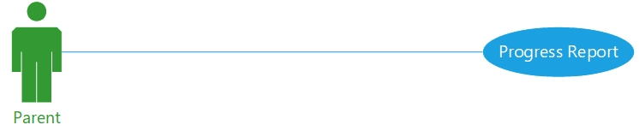

**Figure 8** **Use Case - Progress Report**

**Use Case Detail**

|  |  |  |
| --- | --- | --- |
| **Use Case ID** | UC_07 | |
| **Use Case Name** | Progress Report | |
| **Description** | Child’s progress report | |
| **Primary Actor** | Parents | |
| **Secondary Actor** | Children, System | |
| **Pre-Condition** | Internet Connectivity required to download or view progress report | |
| **Post-Condition** | Progress report generated based on child’s | |
| **Basic Flow** | **Actor Action** | **System Action** |
|  | Child will educate from learning module, engage in games and activities | Progress/result report will be generated/updated.  Report can be viewed or saved. |
| **Alternate Flow** | None | |

**Table 3.2.7 Progress Report**

### 3.2.8 Chatbot

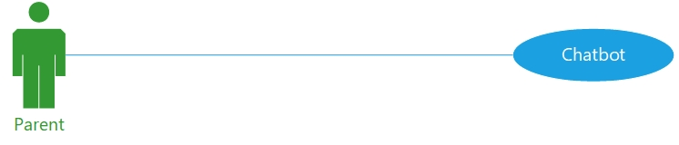

**Figure 9** **Use Case - Chatbot**

**Use Case Detail**

|  |  |  |
| --- | --- | --- |
| **Use Case ID** | UC_08 | |
| **Use Case Name** | Chatbot | |
| **Description** | Chatbot will provide assistance to parent’s queries | |
| **Primary Actor** | Parents | |
| **Secondary Actor** | System | |
| **Pre-Condition** | Internet Connectivity required, trained AI model for assisting the queries | |
| **Post-Condition** | Solution to the problem will be generated | |
| **Basic Flow** | **Actor Action** | **System Action** |
|  | Parent interacts with chatbot and enters their queries. | Chatbot processes the queries using AI trained model.  Chatbot provides relevant response to the query. |
| **Alternate Flow** | None | |

**Table 3.2.8 Chatbot**

### 3.2.9 Notification and Reminders

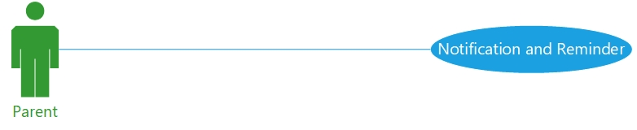

**Figure 10** **Use Case - Notification and Reminders**

**Use Case Detail**

|  |  |  |
| --- | --- | --- |
| **Use Case ID** | UC_09 | |
| **Use Case Name** | Notification and reminders | |
| **Description** | The system sends reminders for children to complete specific activities | |
| **Primary Actor** | Parents | |
| **Secondary Actor** | System | |
| **Pre-Condition** | Device notifications enabled | |
| **Post-Condition** | Timely Relevant Notifications are displayed | |
| **Basic Flow** | **Actor Action** | **System Action** |
|  | User schedules activity and sets notification preferences. | The system retrieves the schedule and sends reminders |
| **Alternate Flow** | None | |

**Table 3.2.9 Notification and Reminders**

### 3.2.10 Settings

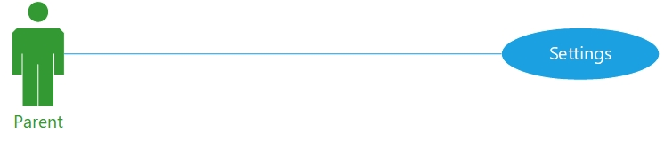

**Figure 11** **Use Case - Settings**

**Use Case Detail**

|  |  |  |
| --- | --- | --- |
| **Use Case ID** | UC_10 | |
| **Use Case Name** | Settings | |
| **Description** | Allows users to customize application preferences | |
| **Primary Actor** | Parents | |
| **Secondary Actor** | System | |
| **Pre-Condition** | User must be logged in and have user interface for settings | |
| **Post-Condition** | Updated settings in the user profile | |
| **Basic Flow** | **Actor Action** | **System Action** |
|  | User customizes app preferences | The system updates the app settings. |
| **Alternate Flow** | If no changes are made, the system retains the previous settings. | |

**Table 3.2.10 Settings**

### 3.2.11 Feedback

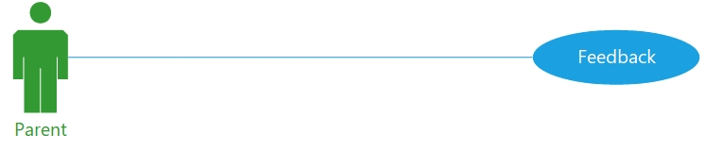

**Figure 12** **Use Case - Feedback**

**Use Case Detail**

|  |  |  |
| --- | --- | --- |
| **Use Case ID** | UC_11 | |
| **Use Case Name** | Feedback | |
| **Description** | Enables users to submit feedback or suggestions | |
| **Primary Actor** | Parents | |
| **Secondary Actor** | System | |
| **Pre-Condition** | User must be logged in, have feedback form/popup and database | |
| **Post-Condition** | Feedback stored in the database | |
| **Basic Flow** | **Actor Action** | **System Action** |
|  | The user fills and submit form | The system stored the feedback in the database |
| **Alternate Flow** | If feedback form is incomplete, the system prompts the user to fill the missing details. | |

**Table 3.2.11 Feedback**

### 3.2.12 Logout

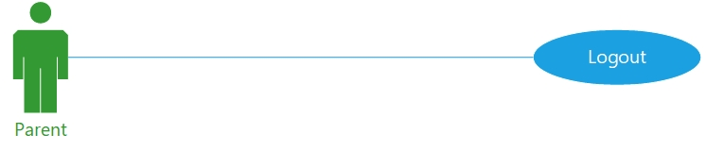

**Figure 13** **Use Case - Logout**

**Use Case Detail**

|  |  |  |
| --- | --- | --- |
| **Use Case ID** | UC_12 | |
| **Use Case Name** | Logout | |
| **Description** | Allows users to securely log out the app | |
| **Primary Actor** | Parents | |
| **Secondary Actor** | System | |
| **Pre-Condition** | User authentication module | |
| **Post-Condition** | User session terminated | |
| **Basic Flow** | **Actor Action** | **System Action** |
|  | The user sends logout request | The system ends the session and redirect user to login screen |
| **Alternate Flow** | Error message is displayed if fails to logout and the session remains active. | |

**Table 3.2.12 Logout**

# **Chapter 4: Design**

## 4.1 Architecture Diagram

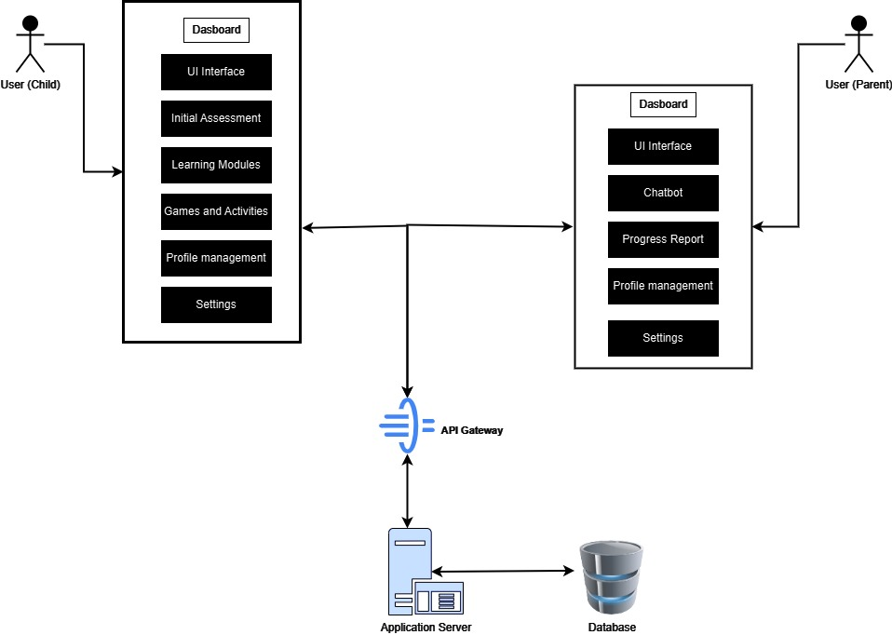

**Figure 14** **Architecture Diagram**

## 4.2 ERD with data dictionary

### 4.2.1 Entity Relationship Diagram

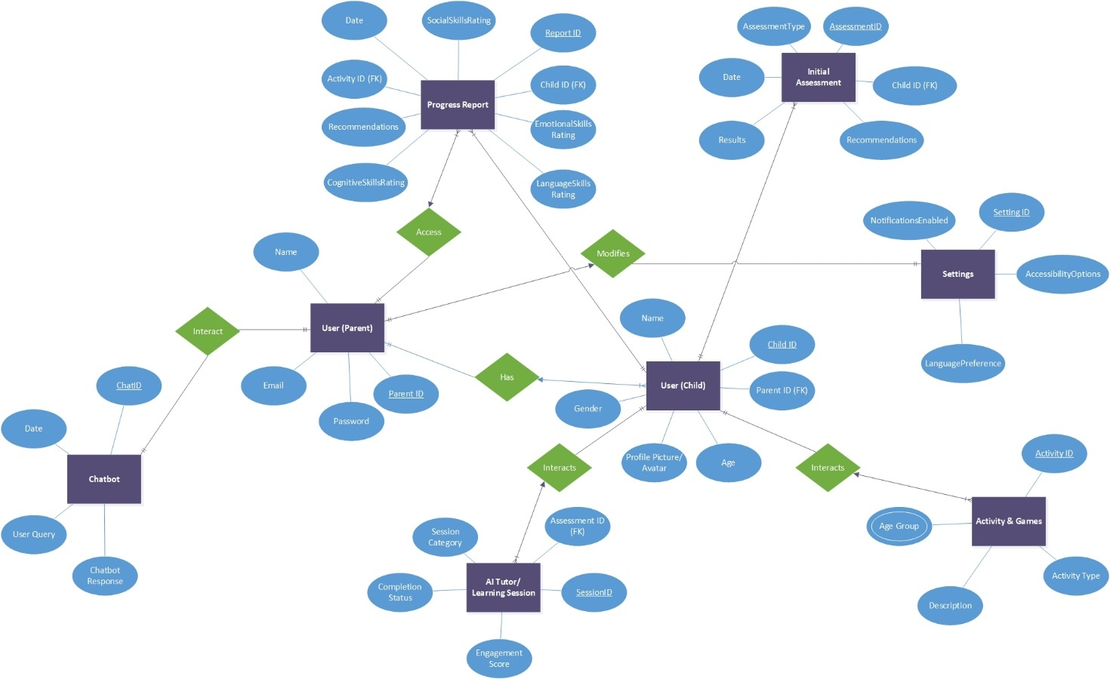

**Figure 15** **Entity Relationship Diagram**

**4.2.2 Data Dictionary**

|  |  |  |  |  |  |
| --- | --- | --- | --- | --- | --- |
| **Table Name** | **Attribute Name** | **Data Type** | **Field Size** | **Required** | **Description** |
| User (Child) | Child_ID | Integer | 25 | Yes | The Unique ID assigned to each child user |
| Name | Varchar | 50 | Yes | child’s name that the user selects for him/her-self |
| Gender | Char | 1 | Yes | Gender of the child  (Male/Female/Other) |
| Age | Integer | 2 | Yes | Age of the child in years |
| Profile Picture/Avatar | Varchar | 255 | No | URL or path to the child’s profile picture or avatar. |
| User (Parent) | Parent_ID | Integer | 25 | Yes | The Unique ID assigned to each Parent user |
| Name | Varchar | 50 | Yes | Full Name of the Parent |
| Email | Varchar | 100 | Yes | Email address of the parent |
| Password | Varchar | 50 | Yes | Encrypted password for parent’s login |
| Initial  Assessment | Assessment_ID | Integer | 25 | Yes | The Unique ID assigned to each assessment |
| AssessmentType | Varchar | 50 | Yes | Type of assessment conducted |
| Date | Date | - | Yes | Date the assessment was performed. |
| Result | Varchar | - | Yes | Detailed results of the assessment. |
| Recommendations | Varchar | - | No | Suggested activities or learning modules based on the assessment. |
| AI Tutor / Learning Session | Session_ID | Integer | 25 | Yes | The Unique ID assigned to each Session |
| SessionCategory | Varchar | 50 | Yes | Type of learning session |
| Engagement Score | Float | - | No | Engagement level scored during the session. |
| Completion Status | Varchar | 25 | Yes | Status of session completion (e.g., Complete, Incomplete). |
| Activity and Games | Activity_ID | Integer | 25 | Yes | The Unique ID assigned to each activity |
| Activity Type | Varchar | 50 | Yes | Type of activity |
| Age Group | Varchar | 10 | Yes | Target age group for the activity. |
| Description | Varchar | - | No | Brief description of the activity or game. |
| Progress  Report | Report_ID | Integer | 25 | Yes | The Unique ID assigned to each report |
| Social Skills Rating | Float | - | No | Rating for the child's social skill improvement. |
| Cognitive Skills Rating | Float | - | No | Rating for the child's cognitive skill improvement. |
| Emotional Skills Rating | Float | - | No | Rating for the child's emotional skill improvement. |
| Language Skills Rating | Float | - | No | Rating for the child's language skill improvement. |
| Date | Date | - | Yes | Date the progress report was generated. |
| Recommendations | Varchar | - | No | Suggested steps or improvements based on the progress report. |
| Chatbot | Chat_ID | Integer | 25 | Yes | The Unique ID assigned to each chatbot |
| User Query | Varchar | - | Yes | The query submitted by the parent or user. |
| Chatbot Response | Varchar | - | Yes | The response provided by the chatbot. |
| Date | Date | - | Yes | Date of the chatbot interaction. |
| Settings | Setting_ID | Integer | 25 | Yes | The Unique ID assigned to each setting |
| Notifications Enabled | Boolean | - | Yes | Whether notifications are enabled for the user. |
| Accessibility Options | Varchar | 100 | No | Options for accessibility settings |
| Language Preference | Varchar | 50 | Yes | Preferred language for the user interface. |

**Figure 16** **ERD Data Dictionary**

### 4.2.3 Logical Schema

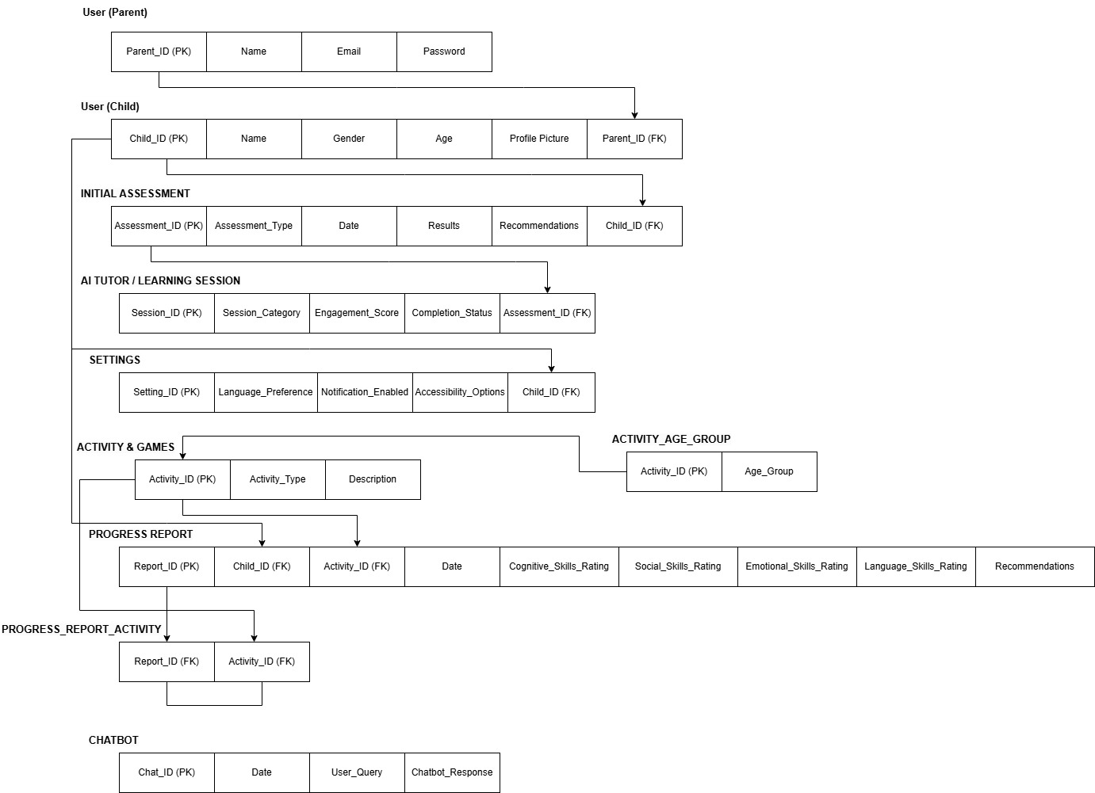

**Figure 17** **ERD Logical Schema**

## 4.3 Data Flow Diagram

### 4.3.1 The Level 0

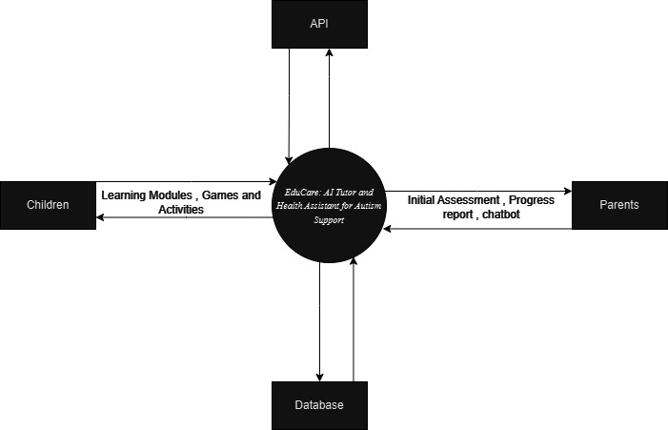

**Figure 18** **Data Flow Diagram Level 0**

### 4.3.2 The Level 1

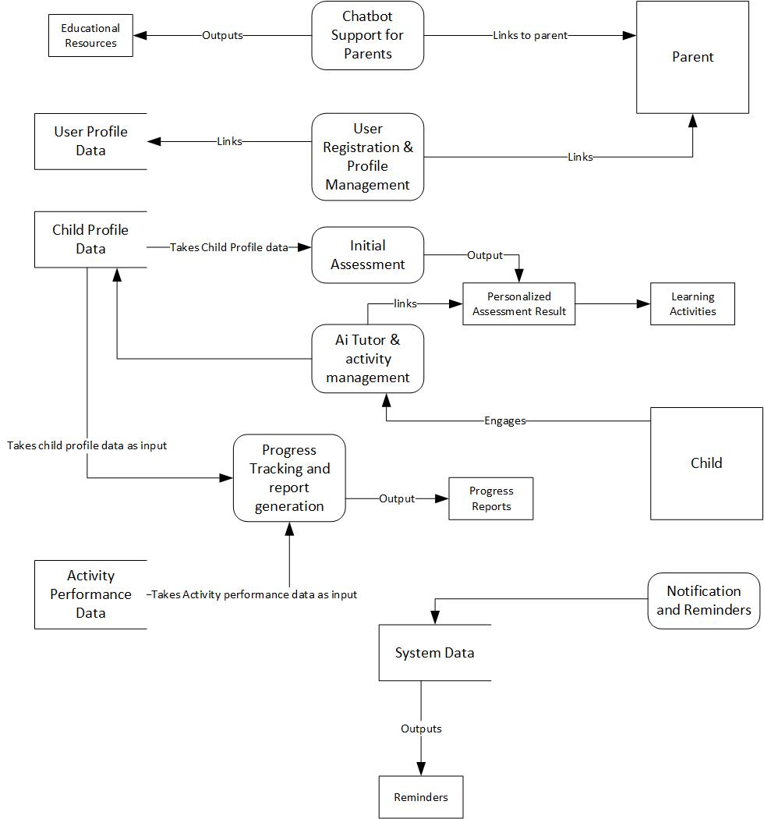

**Figure 19** **Data Flow Diagram Level 1**

## 4.4 Class Diagram

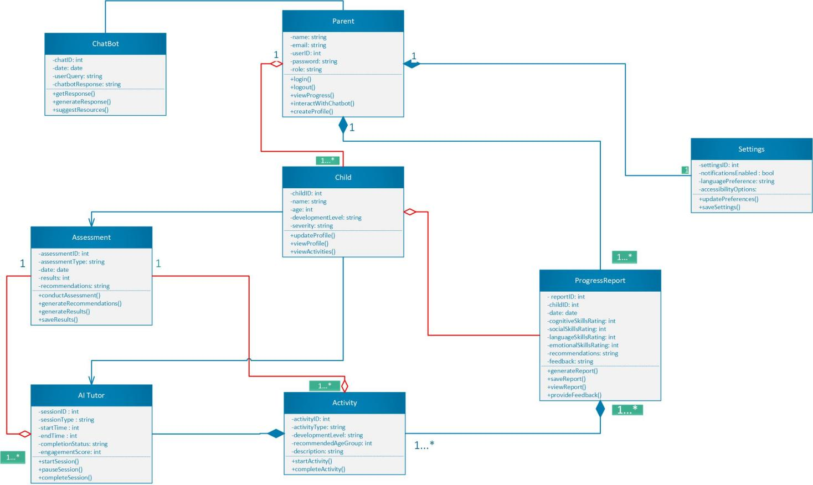

**Figure 20** **Class Diagram**

## 4.5 Activity Diagram

### 4.5.1 Create Account

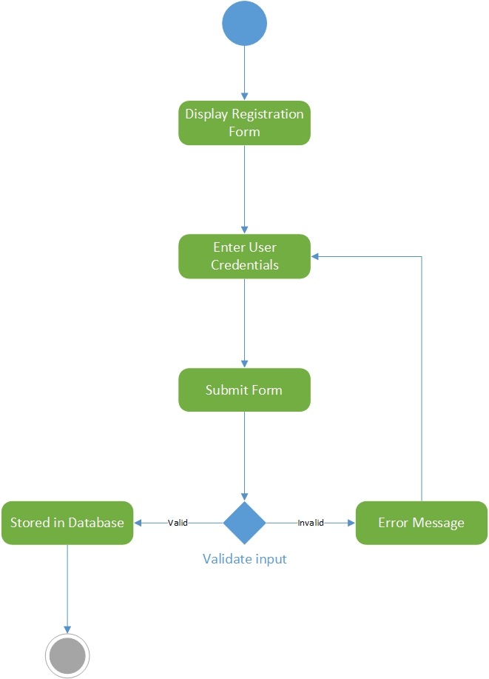

**Figure 21** **Activity Diagram - Login**

### 4.5.2 Login

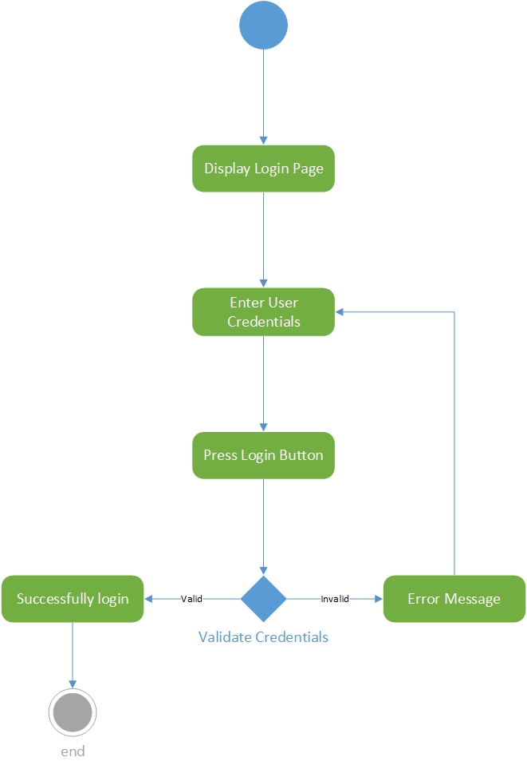

**Figure 22** **Activity Diagram - Create Account**

### 4.5.3 Profile Management

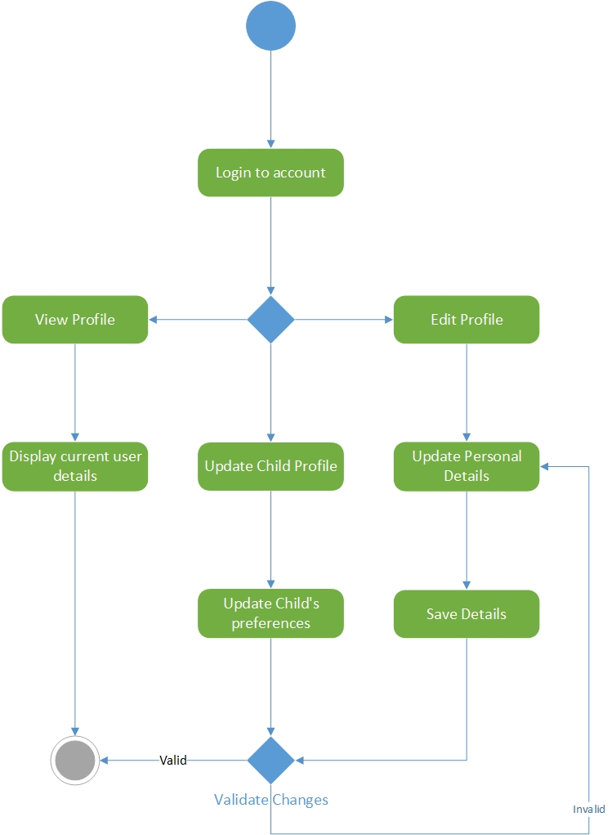

**Figure 23** **Activity Diagram - Profile Management**

### 4.5.4 Initial Assessment

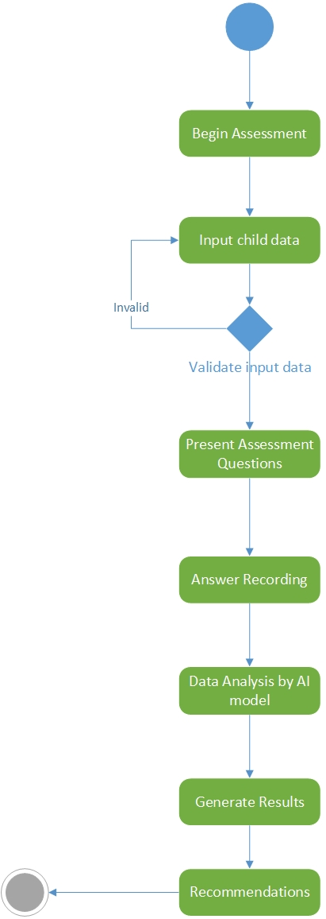

**Figure 24** **Activity Diagram - Initial Assessment**

### 4.5.5 Learning Module

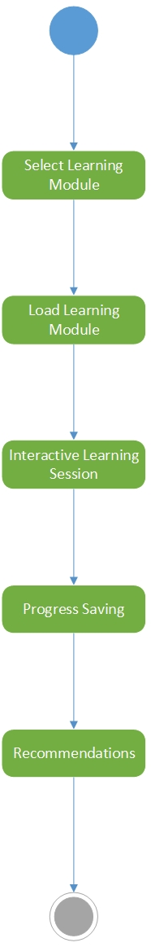

**Figure 25** **Activity Diagram - Learning Module**

### 4.5.6 Games & Activities

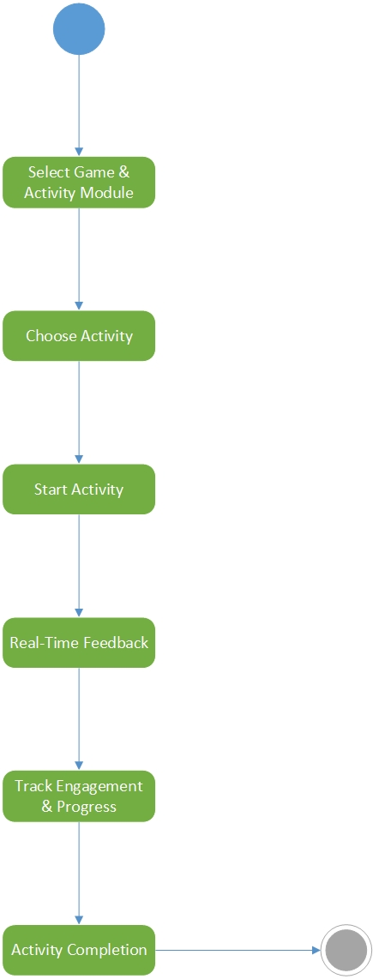

**Figure 26** **Activity Diagram - Games and Activites**

### 4.5.7 Progress Report

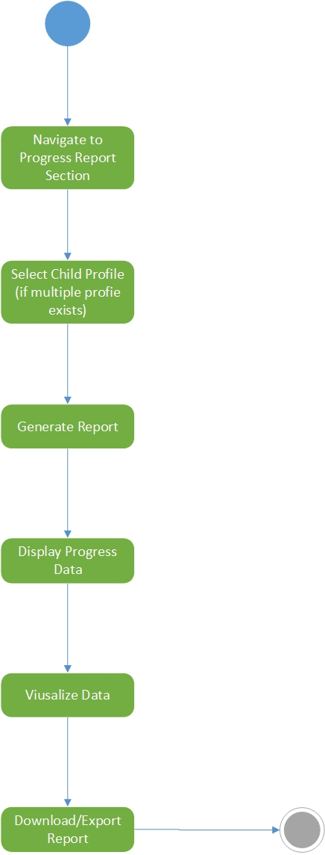

**Figure 27** **Activity Diagram - Progress Report**

### 4.5.8 Chatbot

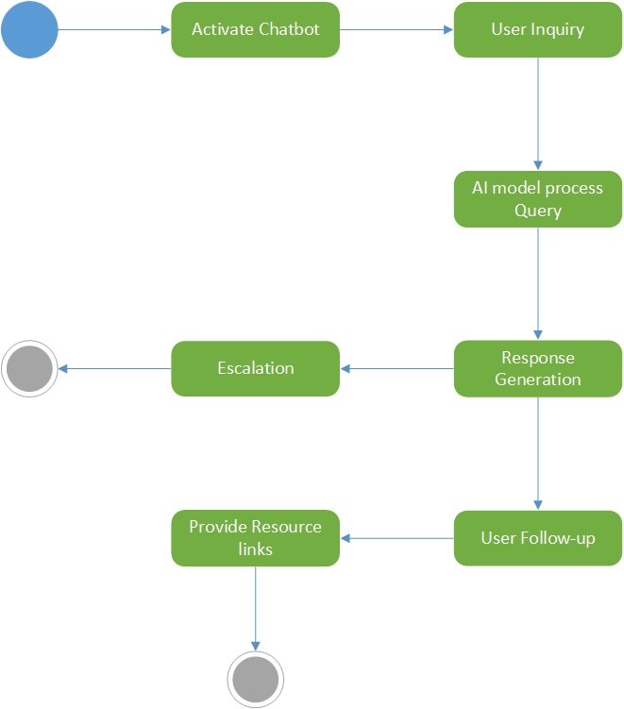

**Figure 28** **Activity Diagram - Chatbot**

### 4.5.9 Notification and Reminders

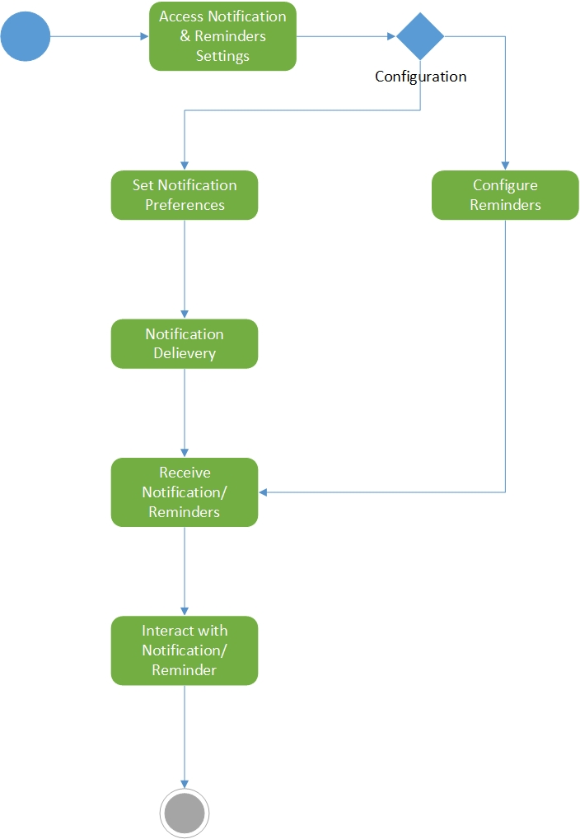

**Figure 29** **Activity Diagram - Notification and Reminders**

### 4.5.10 Settings

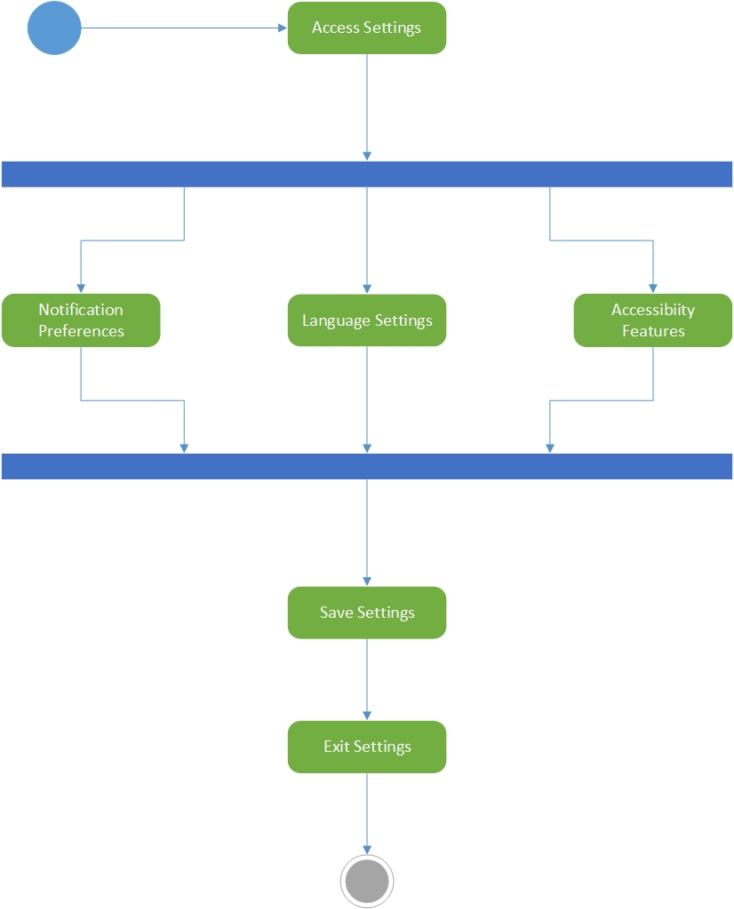

**Figure 30** **Activity Diagram - Settings**

### 4.5.11 Feedback

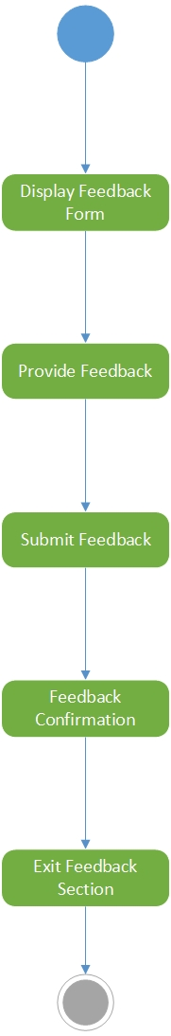

**Figure 31** **Activity Diagram - Feedback**

### 4.5.12 Logout

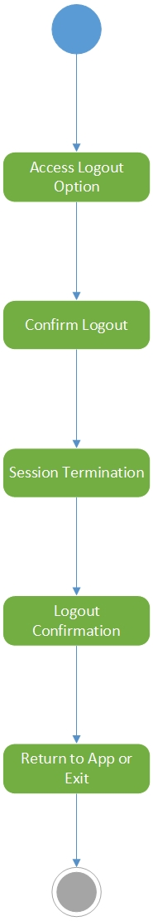

**Figure 32** **Activity Diagram - Logout**

## 4.6 Sequence Diagram

### 4.6.1 Create Account

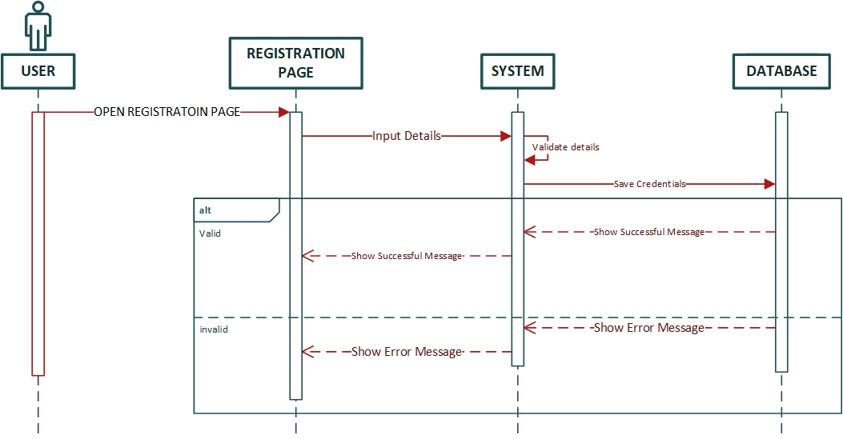

**Figure 33** **Sequence Digram - Create Account**

### 4.6.2 Login

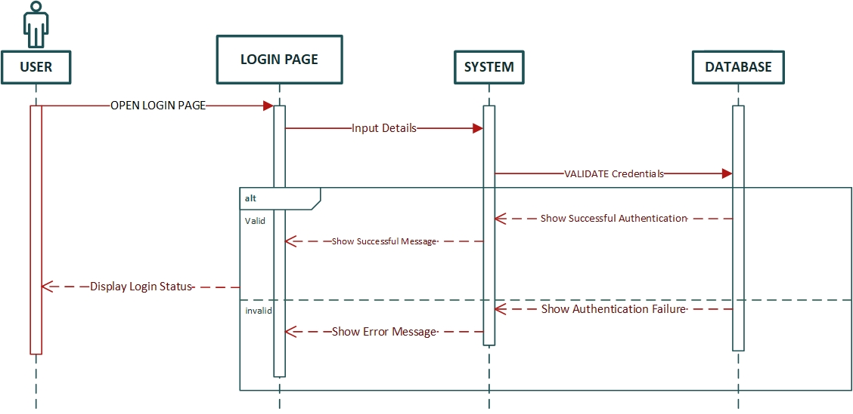

**Figure 34** **Sequence Digram - Login**

### 4.6.3 Profile Management

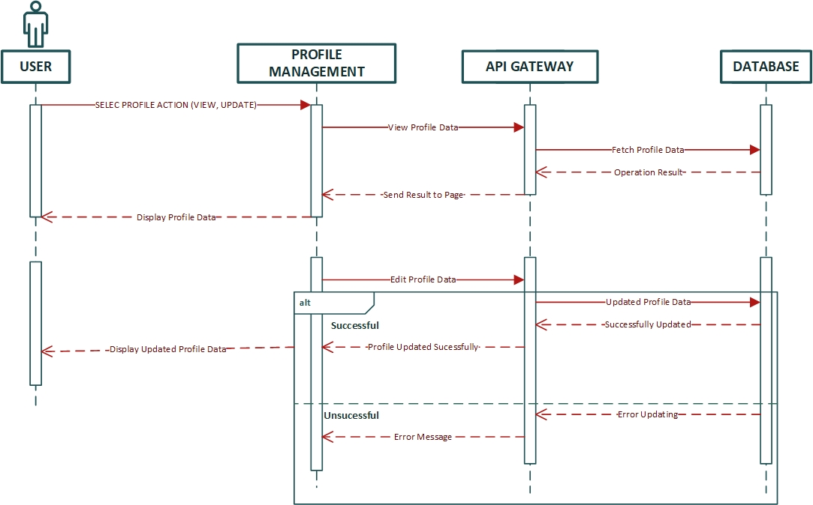

**Figure 35** **Sequence Digram - Profile Management**

### 4.6.4 Initial Assessment

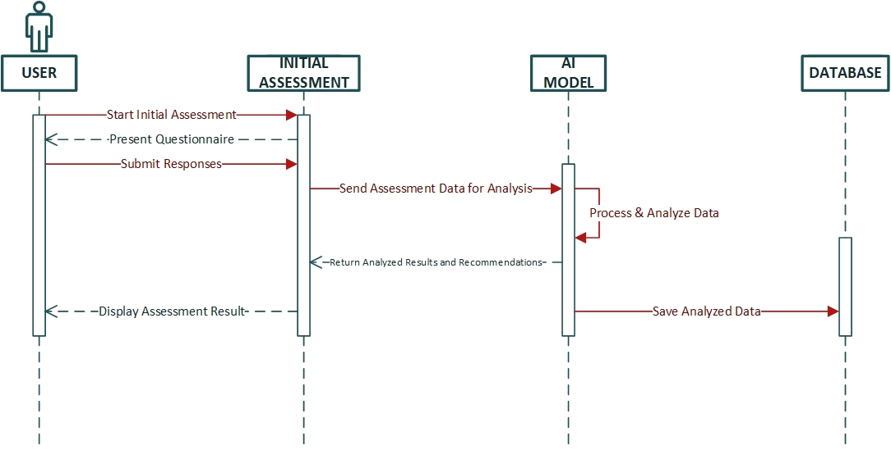

**Figure 36** **Sequence Digram - Initial Assessment**

### 4.6.5 Learning Module

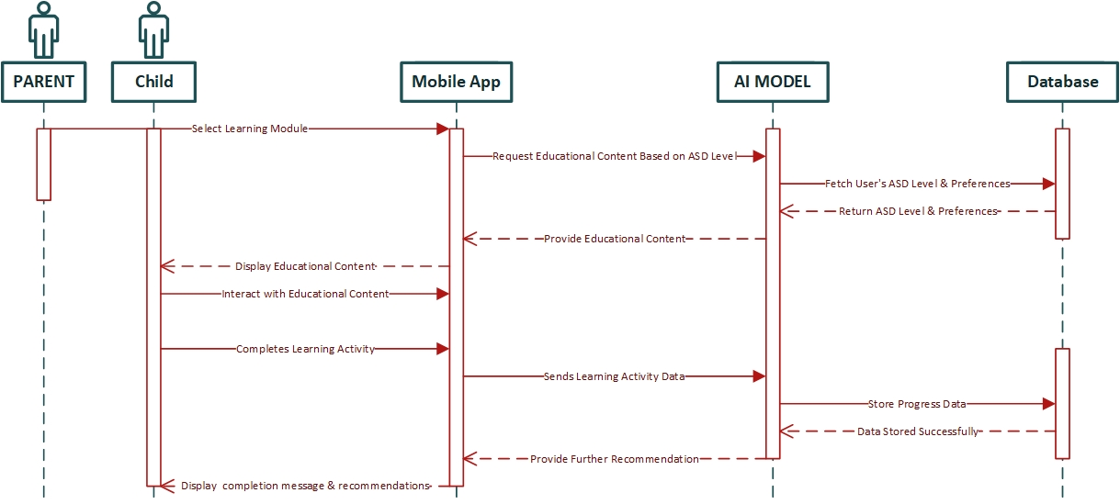

**Figure 37** **Sequence Digram - Learning Module**

### 4.6.6 Games and Activities

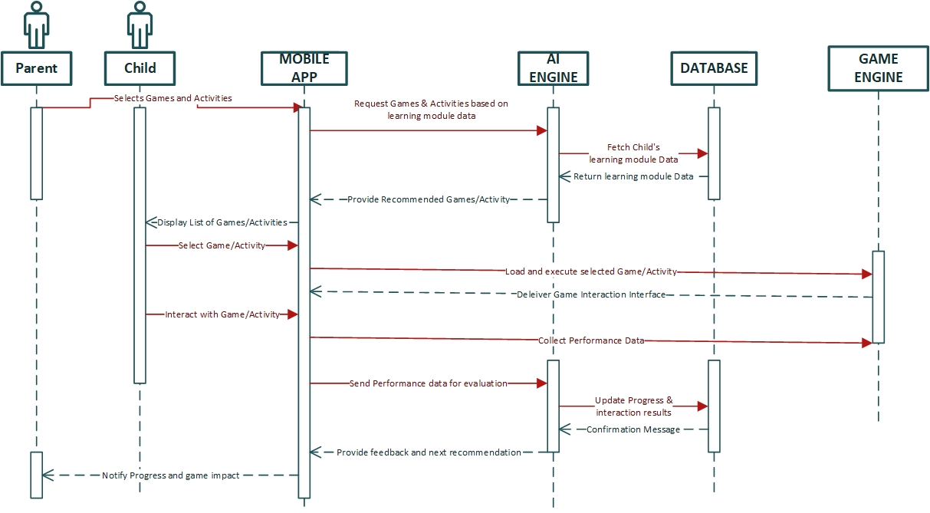

**Figure 38** **Sequence Digram - Games and Activities**

### 4.6.7 Progress Report

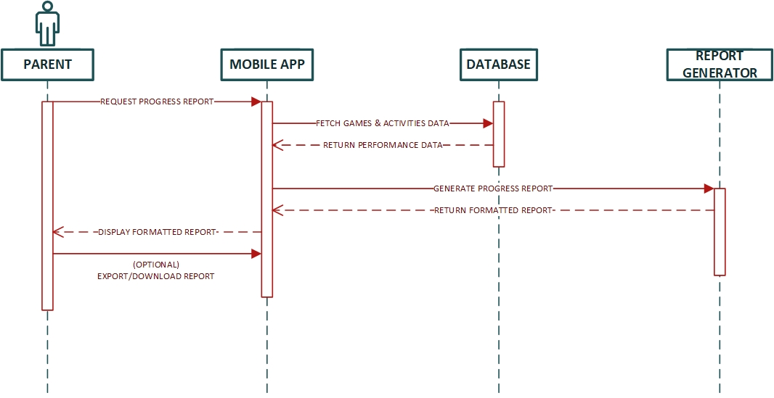

**Figure 39** **Sequence Digram - Progress Report**

### 4.6.8 Chatbot

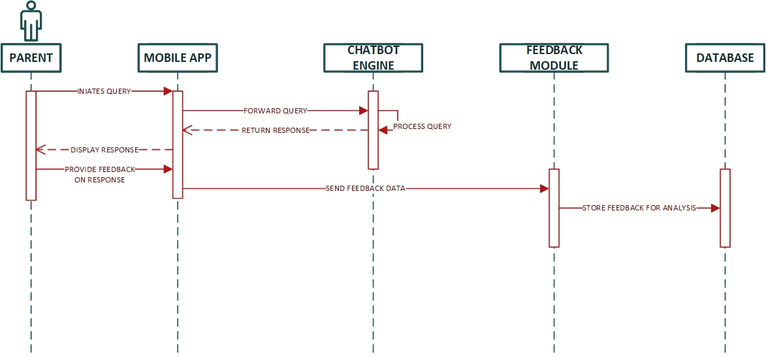

**Figure 40** **Sequence Digram - Chatbot**

### 4.6.9 Notification and Reminders

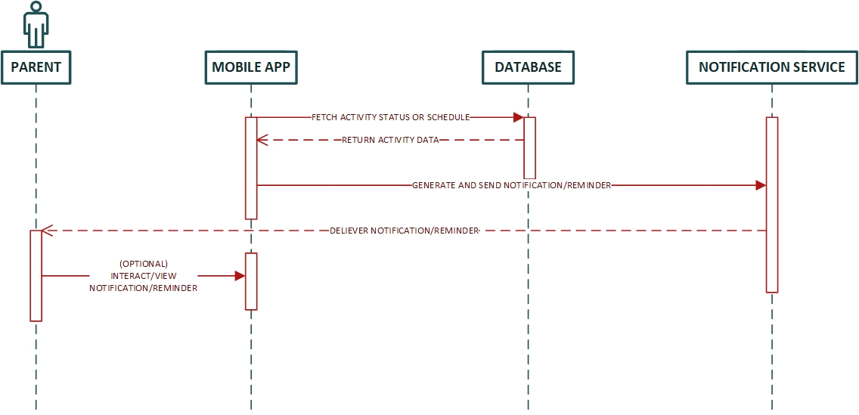

**Figure 41** **Sequence Digram - Notifications and Reminders**

### 4.6.10 Settings

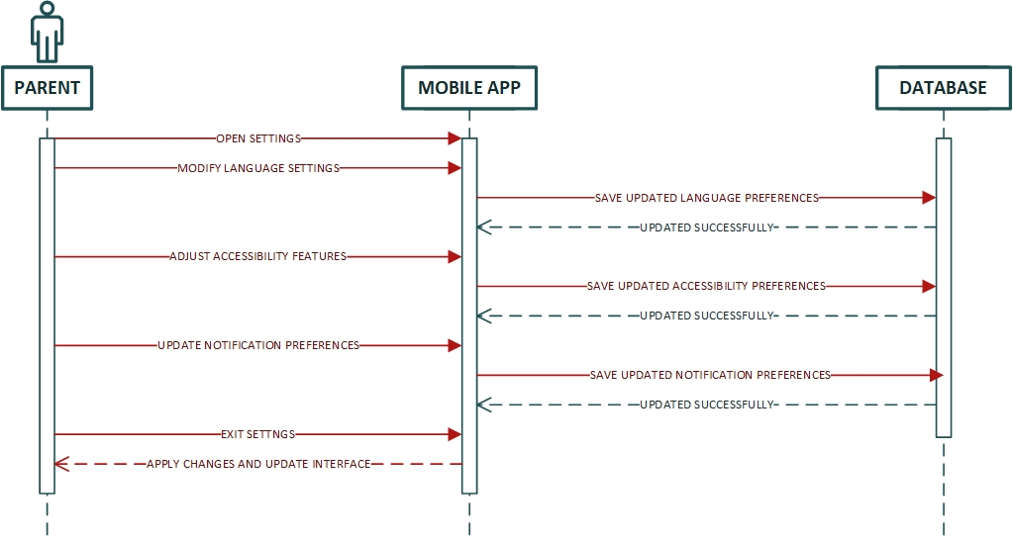

**Figure 42** **Sequence Digram - Settings**

### 4.6.11 Feedback

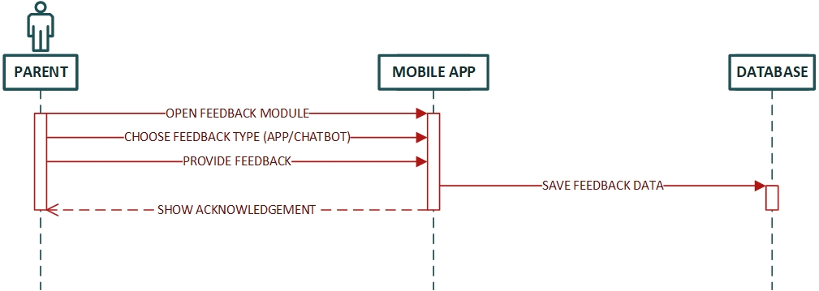

**Figure 43** **Sequence Digram - Feedback**

### 4.6.12 Logout

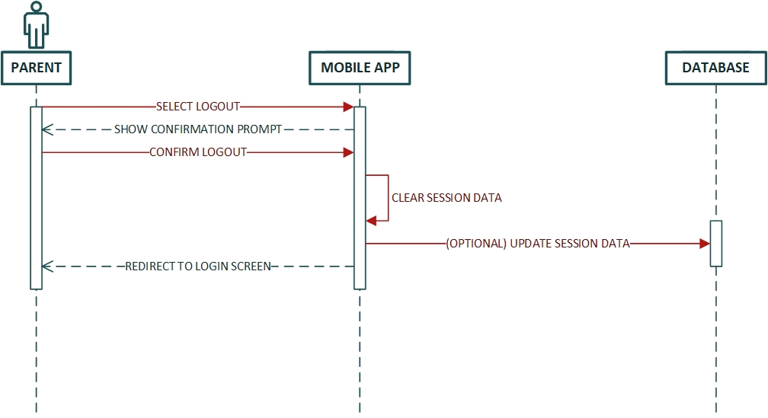

**Figure 44** **Sequence Digram - Logout**

## 4.7 Collaboration Diagram

### 4.7.1 Create Account



**Figure 45** **Collaboration Diagram - Create Account**

### 4.7.2 Login

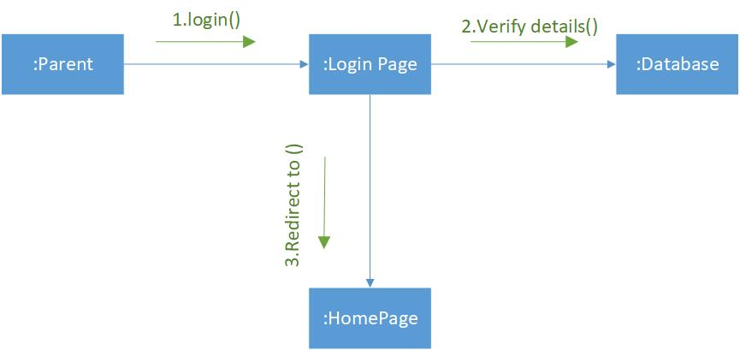

**Figure 46** **Collaboration Diagram - Login**

### 4.7.3 Profile Management

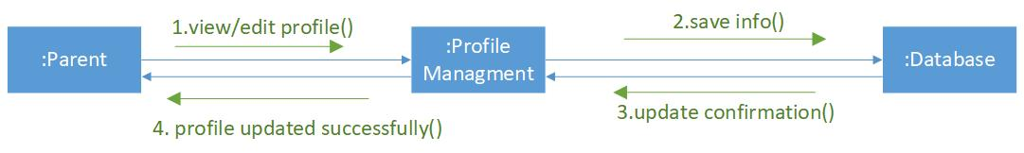

**Figure 47** **Collaboration Diagram - Profile Management**

### 4.7.4 Initial Assessment

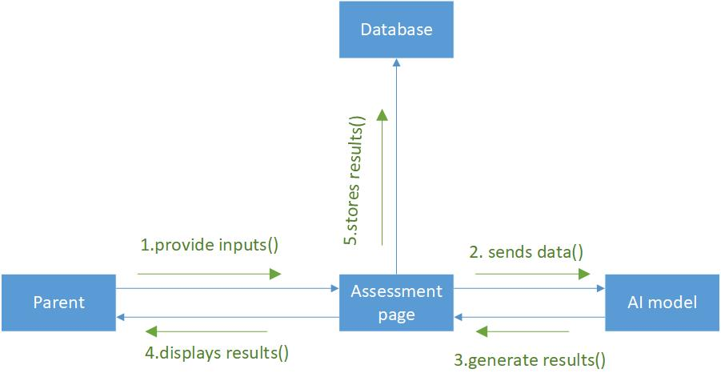

**Figure 48** **Collaboration Diagram - Initial Assessment**

### 4.7.5 Learning Module

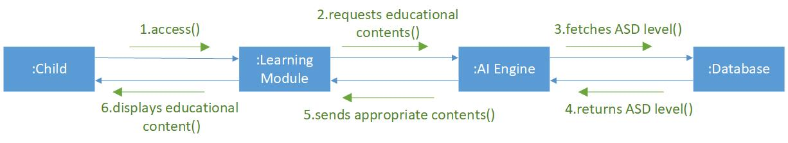

**Figure 49** **Collaboration Diagram - Learning Module**

### 4.7.6 Games and Activities

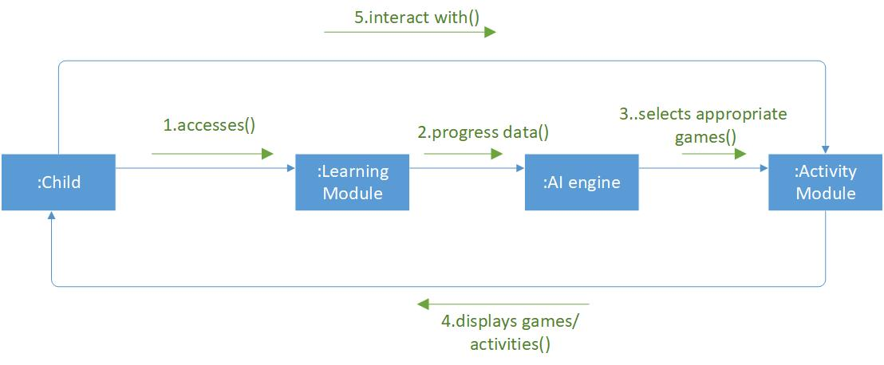

**Figure 50** **Collaboration Diagram - Games and Activities**

### 4.7.7 Progress Report

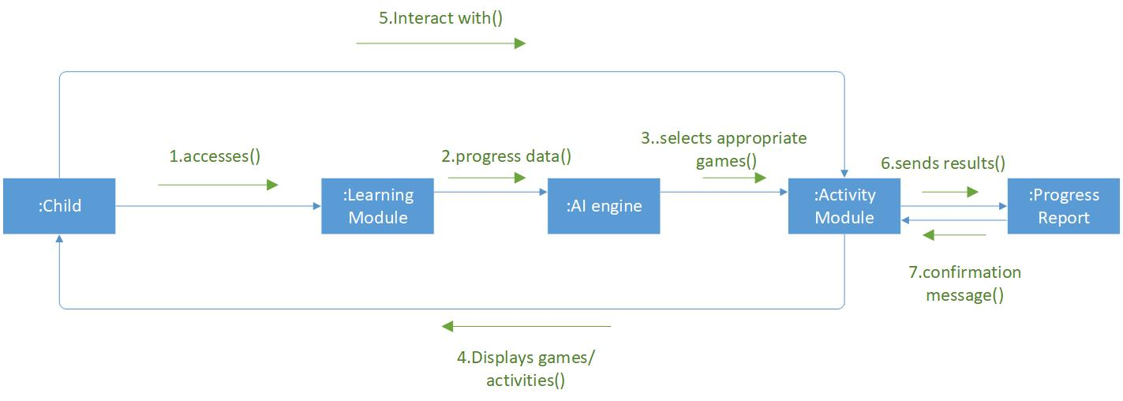

**Figure 51** **Collaboration Diagram - Progress Report**

### 4.7.8 Chatbot

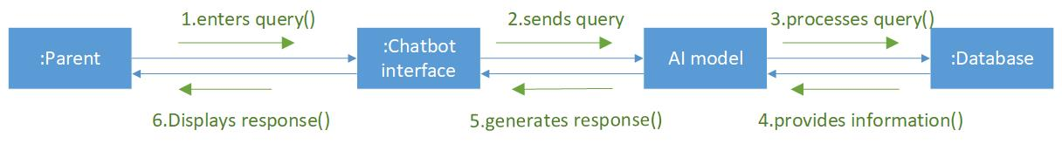

**Figure 52** **Collaboration Diagram - Chatbot**

### 4.7.9 Notification and Reminders

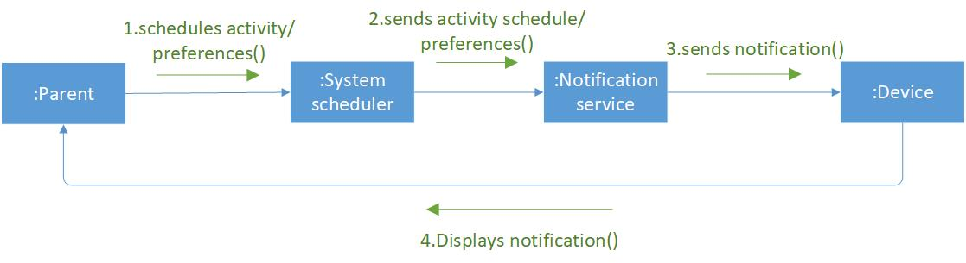

**Figure 53** **Collaboration Diagram - Notifications and Reminders**

### 4.7.10 Settings

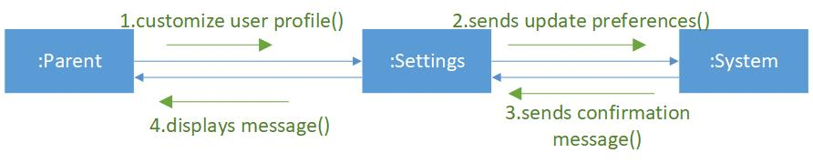

**Figure 54** **Collaboration Diagram - Settings**

### 4.7.11 Feedback

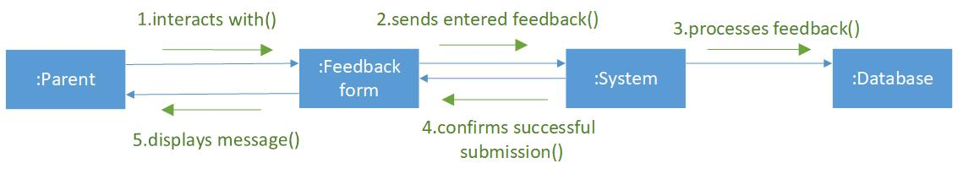

**Figure 55** **Collaboration Diagram - Feedback**

### 4.7.12 Logout

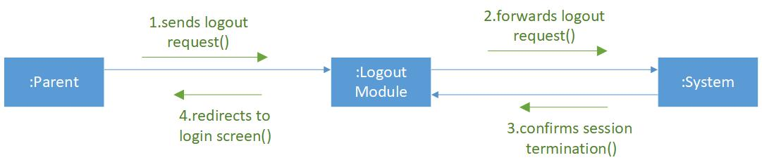

**Figure 56** **Collaboration Diagram - Logout**

## 4.8 State Transition Diagram

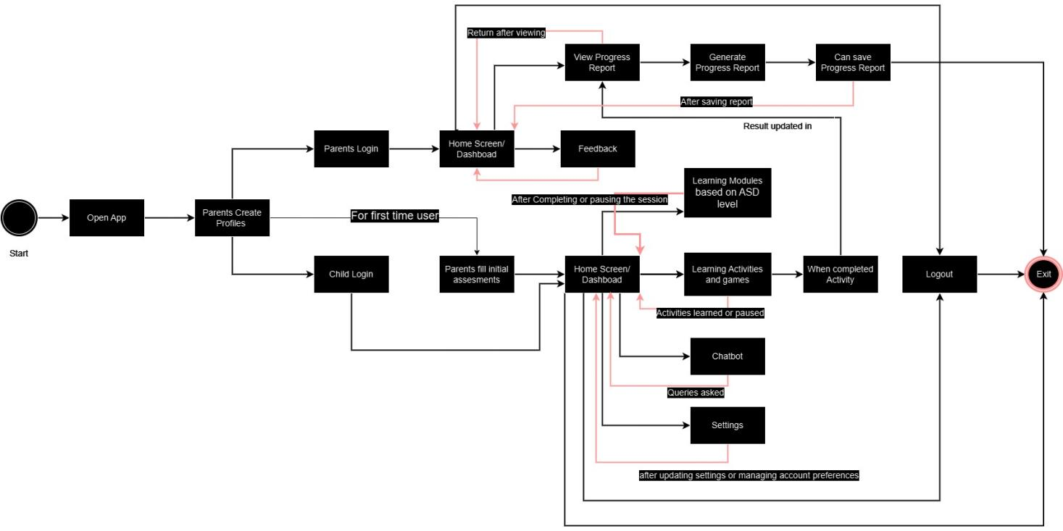

**Figure 57** **State Transition Diagram**

## 4.9 Component Diagram

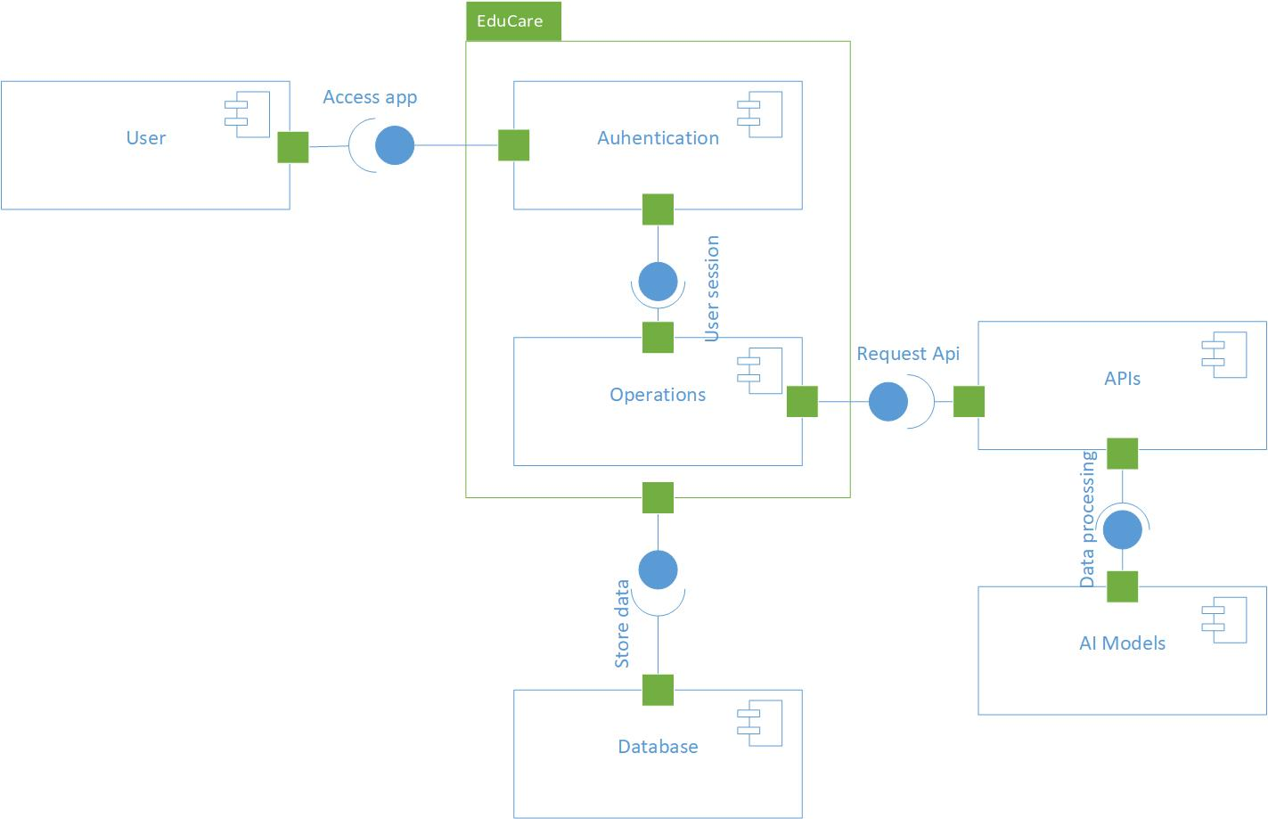

**Figure 58** **Component Diagram**

## 4.10 Deployment Diagram

